

**COMPUTER ENGINEERING**

**DLCA ODD SEM 2021-22/EXPERIMENT 6 NAME:- GAURAV AMARNANI (D7A, 67)**

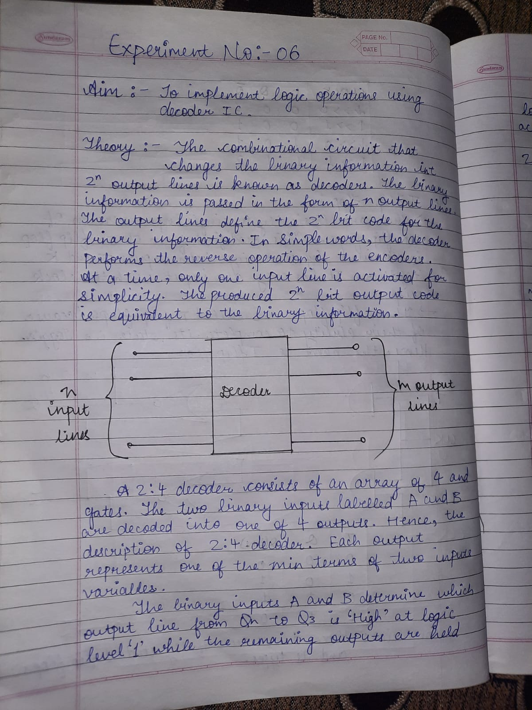

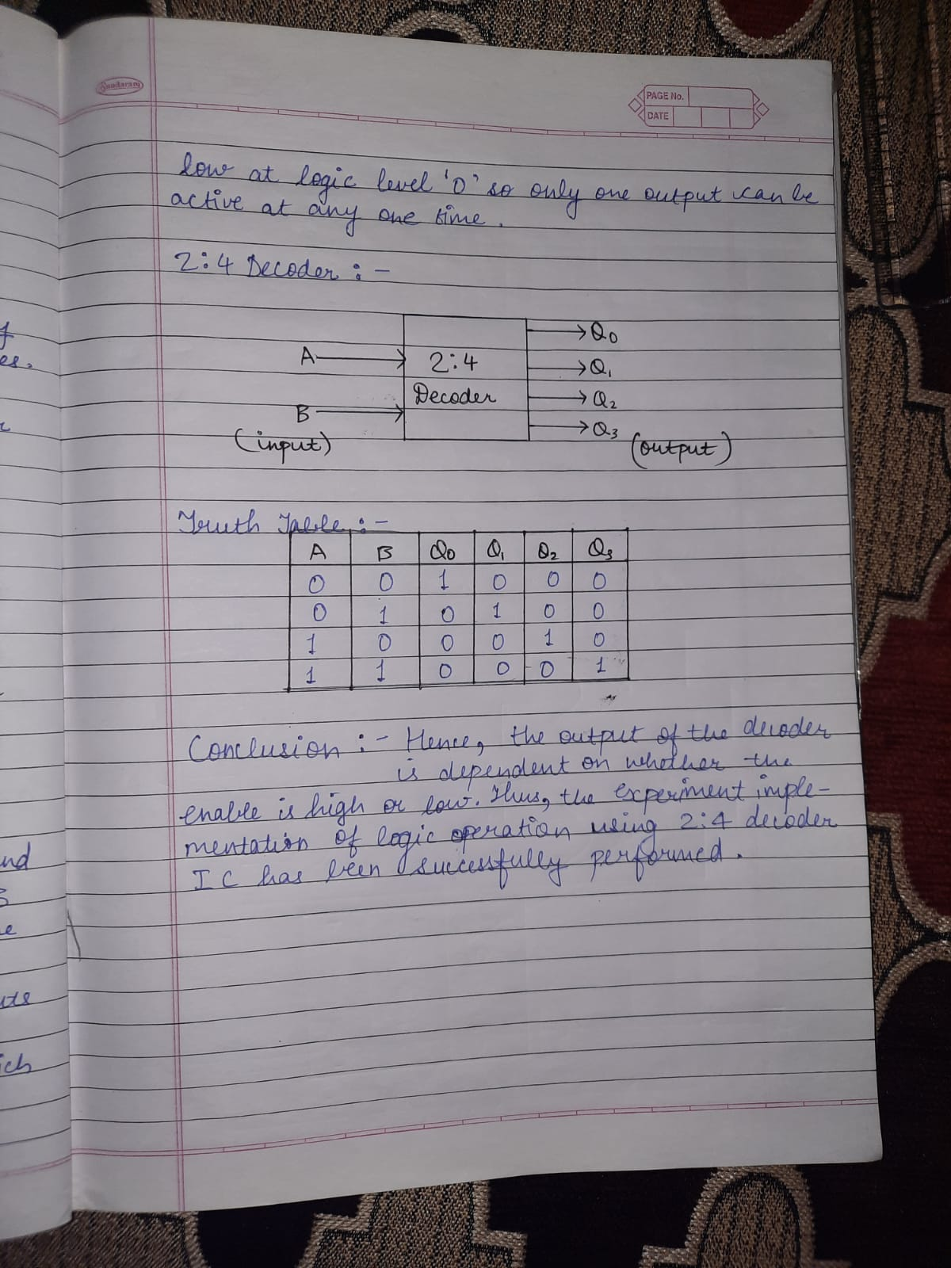

**OUPUT:**

**2:4 Decoder**

